分享: [MURMUR](javascript:desc='';if(window.getSelection)desc=window.getSelection();if(document.getSelection)desc=document.getSelection();if(document.selection)desc=document.selection.createRange().text;void(open('http://murmur.tw/?sharelink='+encodeURIComponent(document.location)));)[facebook](javascript:desc='';if(window.getSelection)desc=window.getSelection();if(document.getSelection)desc=document.getSelection();if(document.selection)desc=document.selection.createRange().text;void(open('http://www.facebook.com/share.php?u='+encodeURIComponent('http://aexmyo.pixnet.net/blog/post/19093363')+'&t='+encodeURIComponent(document.title.split('@')%5b0%5d.replace(/(%5b\s%5d*$)/g,''))));)[PLURK](javascript:desc='';if(window.getSelection)desc=window.getSelection();if(document.getSelection)desc=document.getSelection();if(document.selection)desc=document.selection.createRange().text;void(open('http://www.plurk.com/?qualifier=shares&status='+encodeURIComponent(location.href+'%20('+document.title.split('@')%5b0%5d.replace(/(%5b\s%5d*$)/g,'')+')')));)[twitter](javascript:desc='';if(window.getSelection)desc=window.getSelection();if(document.getSelection)desc=document.getSelection();if(document.selection)desc=document.selection.createRange().text;void(open('http://twitter.com/?status='+encodeURIComponent(location.href+'%20('+document.title.split('@')%5b0%5d.replace(/(%5b\s%5d*$)/g,'')+')')));)

         因為時間上的不足，目前進度直接跳至執行階段中的**掙值分析**部份  
            (為重要必考題)。  
  
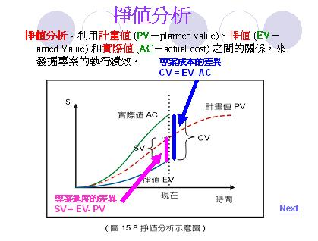  
  
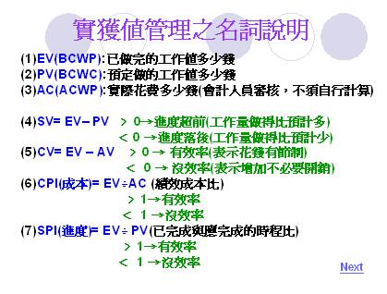  
  
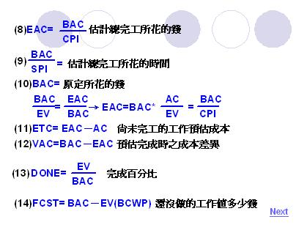  
  
課堂範例:  
  
